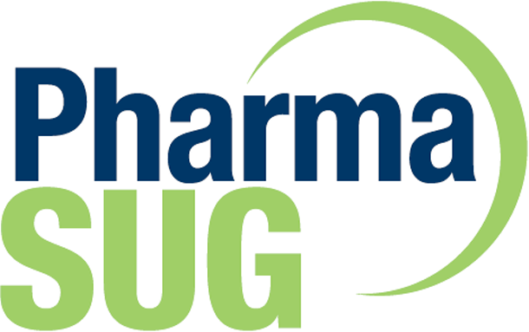
PHARMASUG SINGLE DAY EVENT 2020
Friday October 23, 2020 – A Virtual Meeting
CORPORATE SPONSORSHIP FORM
GENERAL SPONSOR: ( ) US $850.00
Premier SPONSOR: ( ) USD $2300 ; Gold SPONSOR: ( ) USD $1200

COMPANY: _______________________________________
ADDRESS:_________________________________________________________________________________
City: _________________ State: _______Zip Code: ________ Country ________________
CONTACT: Last Name __________________ , First Name _________________ Title: _______________________
EMAIL: _________________________ PHONE: ___________________ FAX: _____________________
2ND CONTACT: Last Name ________________, First Name ________________ Title: _______________________
EMAIL: _________________________ PHONE: ___________________ FAX: _____________________
PAYMENT:
( ) By Company Check. Make check payable to: “PharmaSUG”. Mail check to: PharmaSUG, 1818 MLK Jr. Blvd., Suite 106, Chapel Hill, NC 27514, USA
( ) By Credit Card - Credit Card Type: ( ) American Express ( ) VISA ( ) Master Card ( ) Discover
Account number: _______________________ Expiration Date: __________ Security code: _______
Name on Credit Card: ________________________________
Address of Card Holder in C C Bank’s Record: ______________________________________________________
Signed: _____________________________________Date: _________________________
For Credit Card payment, please fax signed form to: (888)268-0065
( ) By Wire Transfer – Please send us an email – NC2020sde@pharmasug.org - for wire transfer instruction – Once payment is received, a receipt will be emailed to you. THANK YOU FOR YOUR SPONSORSHIP!

