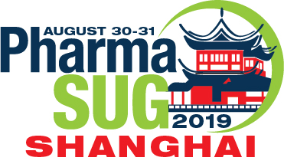
PHARMASUG CHINA 2019 – Corporate Sponsorship Form
SPONSORSHIP LEVELS (Please check one):
( ) Diamond Sponsor – US $5,000 (¥35,000 Chinese Yuan)
( ) Platinum Sponsor - US $4,000 (¥28,000 Chinese Yuan)
( ) Gold Sponsor - US $3,000 (¥21,000 Chinese Yuan)
( ) Silver Sponsor - US $2,000 (¥14,000 Chinese Yuan)
( ) Patron – US $500 (¥ 3,500 Chinese Yuan)
COMPANY: _______________________________________________________________________
ADDRESS:_______ ________________________________________________________________
City: ____________i___ State: _______Zip Code: _________ Province: ________Country ______
CONTACT: Last Name ______ , First Name _____ EMAIL: ____________________________________
PHONE: Country code______ City code ______ Phone # _______________FAX: ____________________
PAYMENT:
( ) By Company Check in USD (no personal check). Make check payable to: “PharmaSUG”. Mail check to: PharmaSUG, 1818 MLK Jr. Blvd., Suite 106, Chapel Hill, NC 27514, USA
( ) By Credit Card
Credit Card Type: ( ) American Express ( ) VISA ( ) Master Card ( ) Discover
Account number: _______________________ Expiration Date: __________ Security code: _______
Name on Credit Card: ___________________________ Address of credit card holder on file with bank: ____________________________________________________________________________________________
Signed: _____________________________________Date: _________________________
For Credit Card payment, please email or fax the signed form to: (888) 268-0065 – USA Fax number
( ) By Wire Transfer – Please send us an email for wire transfer instruction – sponsor@pharmasugchina.com
Once payment is received, a receipt will be emailed to you. THANK YOU FOR YOUR SPONSORSHIP!

